William McGraw & Kameron DeDecker

Excalibur login information 2
Topic 1: Analysis mode on list pages 2
Steps 2
Topic 2: Exporting Data to Excel using OData 3
Steps 3
Topic 3: Excel report layouts 4
Steps 4
Testing your layout 5

Excalibur login information

URL: https://userconference.camelot3plcloud.com/EXCALIBUR/?company=W03
Username: EXCEL2025
Password: ExcelUC2025!

Past conference materials on the client portal

Topic 1: Analysis mode on list pages

This lesson will demonstrate creating ad-hoc analyses and reports on lists. These reports can be quickly shared with coworkers. In this scenario, we are going to create a report that shows the sum of invoice revenue in each month. Analysis mode in Business Central is available starting in Excalibur version 23.0.

Steps
- In Excalibur, navigate to Posted Invoices
- On the action bar, choose Analysis Mode
- Create a new tab and rename it to [Your Assigned Code] + Client activity over time.
- Go to the Columns menu and remove all columns (select the box next to the Search field on the right twice).
- Turn on the Pivot Mode toggle (located above the Search field on the right).
- Drag Invoice Date Year, Invoice Date Month, and Client to the Row Groups area.

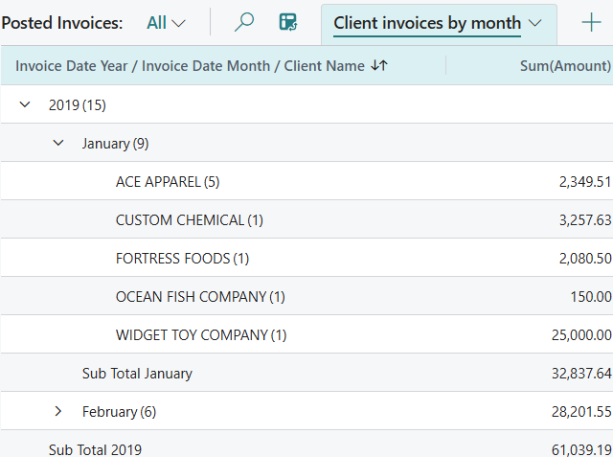

Analysis tabs are only created for your user, but they can be shared with coworkers.
- Select the analysis tab name and choose Copy link from the menu.
- On the dialog, change the link type as needed and choose Copy.
- Send the link to a coworker.

Topic 2: Exporting Data to Excel using OData

This lesson will demonstrate a method of automatically importing data from Excalibur into Excel requiring minimal setup. Then by using basic Excel PivotTables, build a simple dashboard to get quick insights out of pending transaction data. In this scenario, we are going to create a report that shows the number of pending transactions assigned to operators.

Steps
- In Excalibur, navigate to Web Services and search for UCExcelTrx
- Select the hyperlinked value in OData V4 URL to open a new browser tab.
- Copy the URL in the address bar and close the browser tab.
- In a new Excel workbook, rename Sheet1 to “Dashboard.”
- From the Data tab, select Get Data > From Other Sources > From OData Feed.
- Select Ctrl+V to paste the URL and choose OK.
- Authenticate using the basic authentication type with the credentials on page 1, then choose Load to create the query connection.
- Rename Query1 to “Transaction List.”
- From the Table Design menu enter “Transaction” into Table Name.
- Select Insert>PivotTable>From Table/Range and make sure that the Transactions table is specified in the Table/Range.
- Select Existing Worksheet and select cell O1 of the Dashboard sheet, then select OK.
- From the PivotTable Analyze tab enter Trx by Operator into PivotTable Name.
- Build the PivotTable as follows
  - Filters
    - Doc_Date
    - Document_Type
  - Rows
    - Assigned_User
  - Values
    - Document

This workbook can be refreshed using web service.
- Manual refresh
  - From the Data tab select Refresh All (Ctrl+Alt+F5)
- Scheduled refresh
  - From the Query tab select Properties
  - From the Query Properties dialog toggle the Refresh every X minutes field and set the interval to 30 minutes

Topic 3: Excel report layouts

This lesson will demonstrate a method of creating an Excel layout for a report. This activity includes a section for independent work where the attendee will be asked to modify their Excel layout as they see fit. In this scenario, we are going to create a report that shows the sum of revenue per client per service.

Steps
- In Excalibur, navigate to Report Layouts.
- Search for 37005339 and choose Run Report.
- On the request page, choose Send to, then Microsoft Excel Document (data only), and then OK.
- Open the downloaded file in Excel.
- Create a new worksheet and rename it to Revenue
- On the ribbon, choose Insert > PivotTable > From Table/Range and specify the Data table in Table/Range.
- Choose Existing Worksheet to place the PivotTable in an existing worksheet.
- Select cell B8 of the Revenue worksheet to place to PivotTable in cell A1, then choose OK to create the PivotTable.
- Select the PivotTable, then enter Client Revenue by Service into PivotTable Name located in the PivotTable Analyze menu.
- Build the PivotTable as follows:
  - Columns
    - PWBillingDetail_Client
  - Rows
    - PWBillingDetail_ServiceCode
  - Values
    - PWBillingDetail_ChargeAmount (sum)
- In cell B2 type in a custom title (e.g. Client Revenue per Service Code).
- Save and close the workbook.
- In Excalibur, choose New Layout on the Report Layouts page.
- In Report ID, enter 37005339.
- In Layout Name, enter Billing Edit List_ + [Your Assigned Code].
  - Example: Billing Edit List_Excel1
- In the Format Options field, choose Excel.
- Choose OK, then drag and drop your Excel file into the dialog box.

Testing your layout
- On the Report Layouts page, search for Billing Edit List_ + [Your Assigned Code].
  - Example: Billing Edit List_Excel1
- Choose Run Report.
- On the request page, choose Download.
- Open the downloaded file in Excel and confirm that your layout is visible.

